Microsoft Teams

# 1. Introduction

## 1.1 Opening



## 1.2 Learning Objectives

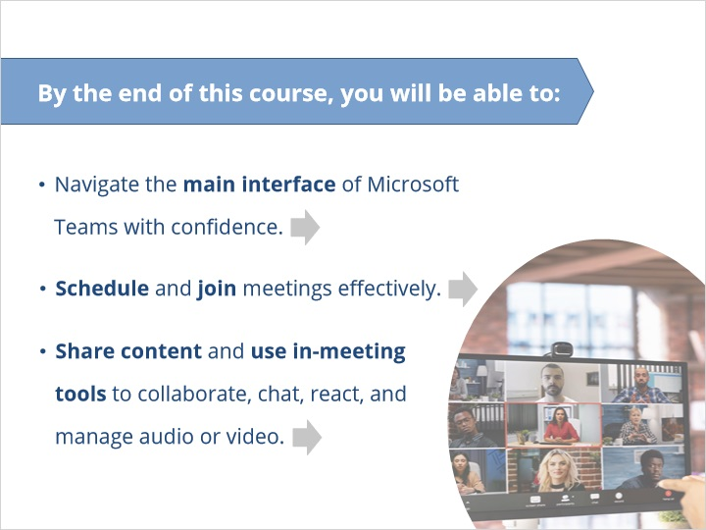

# 2. Basic Layout

## 2.1 Basic Layout (video)

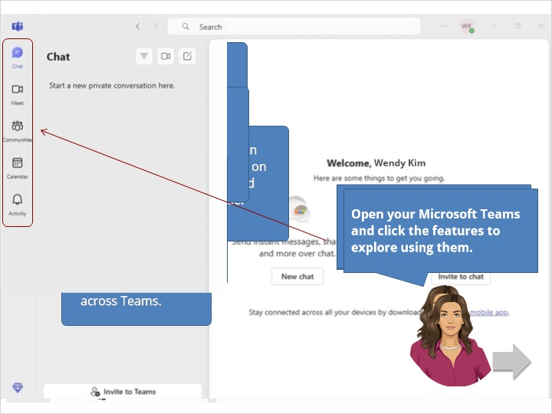

# 3. Scheduling a Meeting

## 3.1 Schedule a meeting (video)

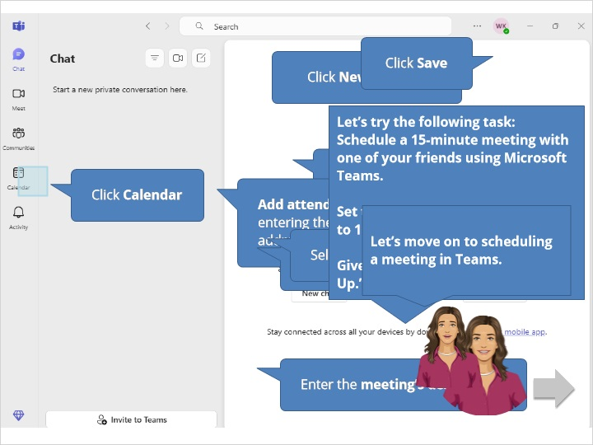

# 4. Join a meeting

## 4.1 Join a meeting

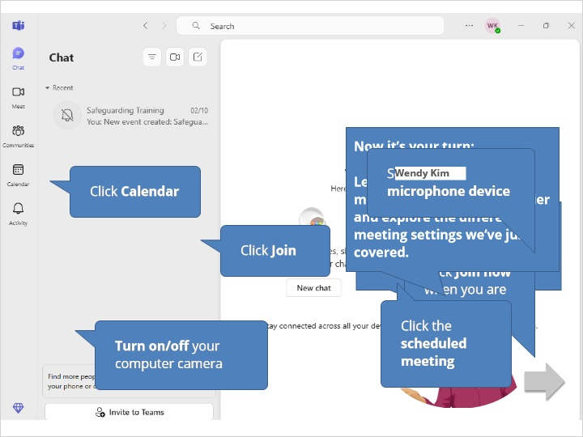

# 5. In the meeting

## 5.1 Chat

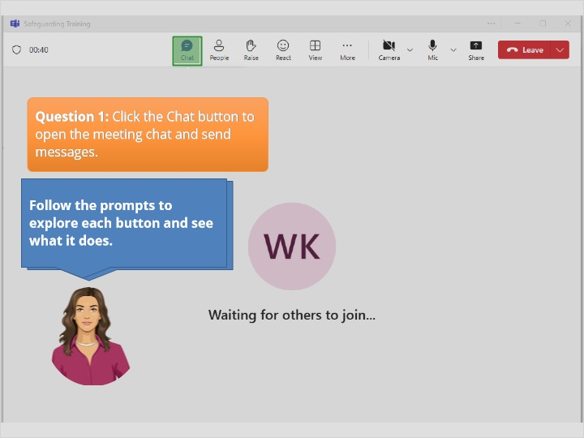

### Rectangular Hotspot 1 (Slide Layer)

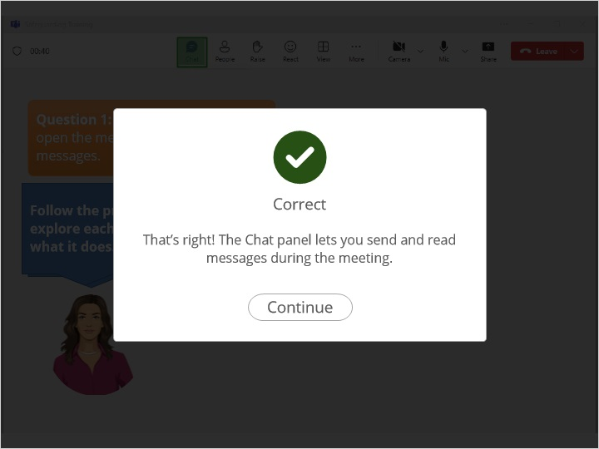

### Try Again (Slide Layer)

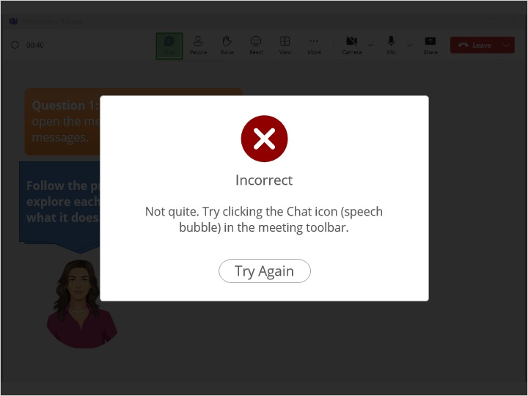

## 5.2 People

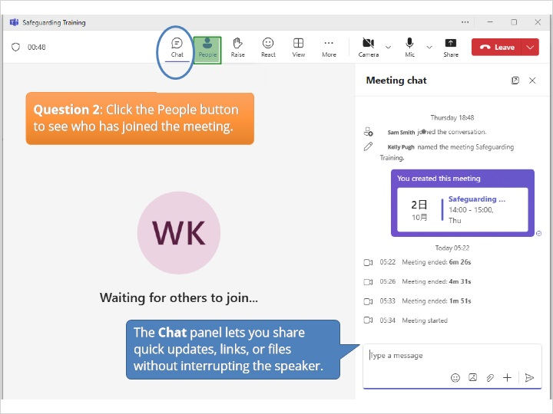

### Rectangular Hotspot 1 (Slide Layer)

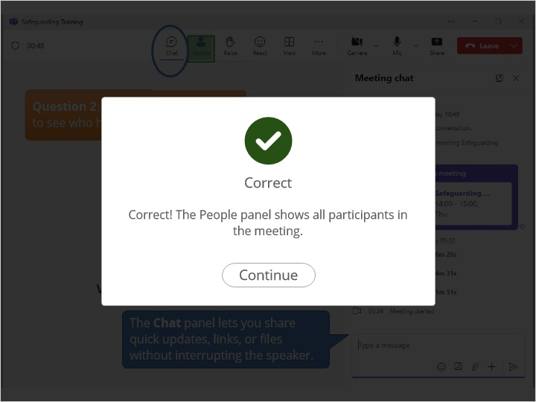

### Try Again (Slide Layer)

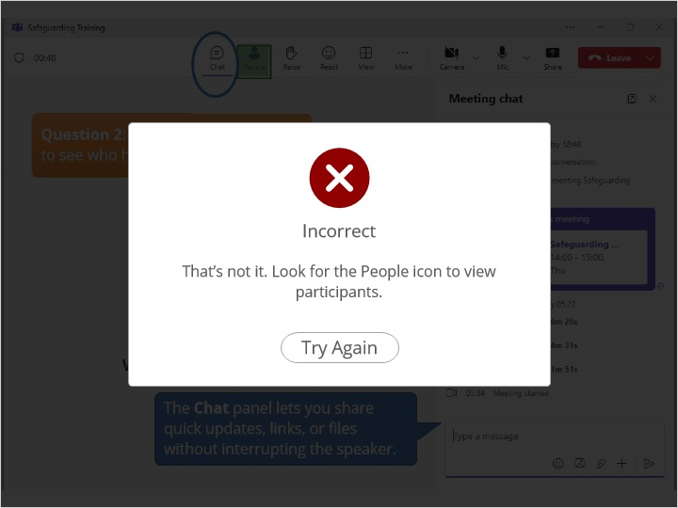

## 5.3 Raise

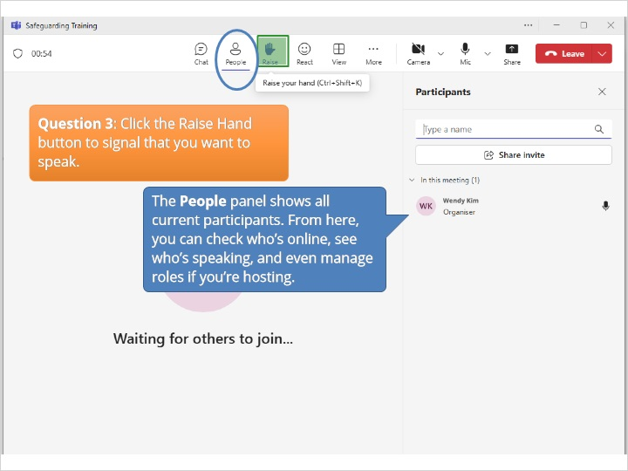

### Rectangular Hotspot 1 (Slide Layer)

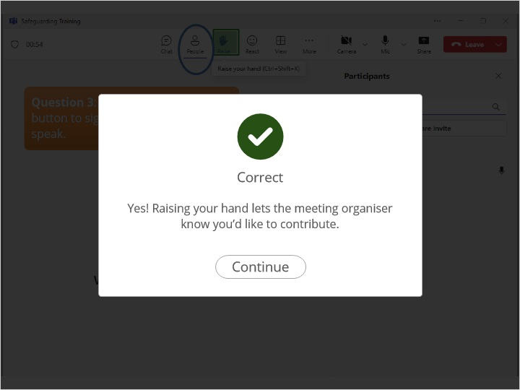

### Try Again (Slide Layer)

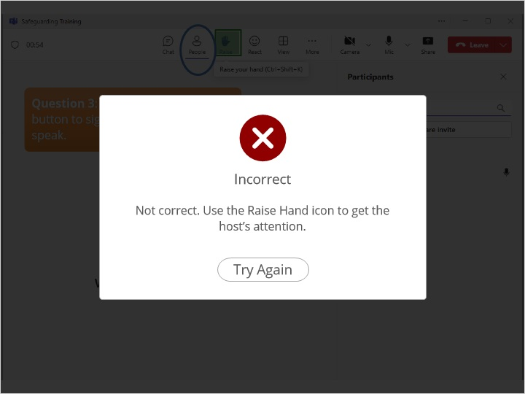

## 5.4 More

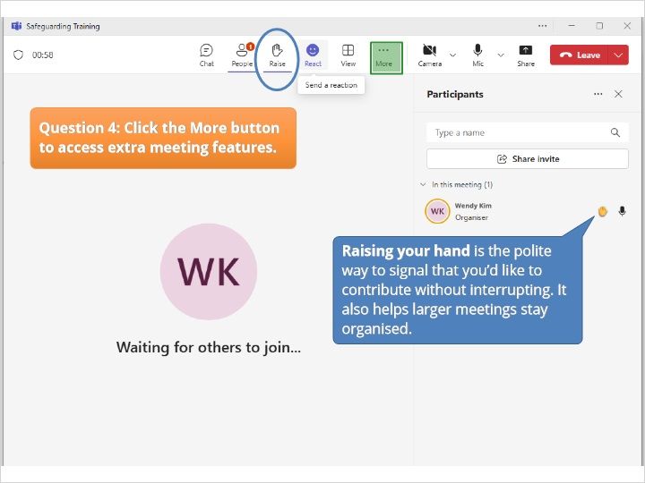

### Rectangular Hotspot 1 (Slide Layer)

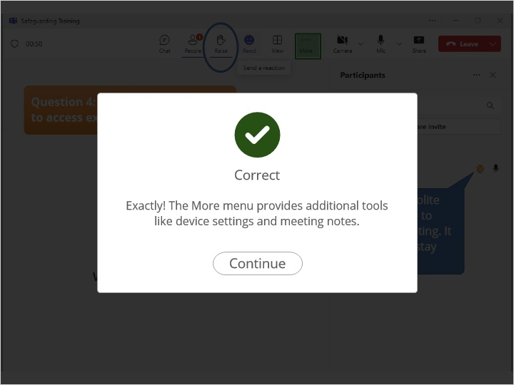

### Try Again (Slide Layer)

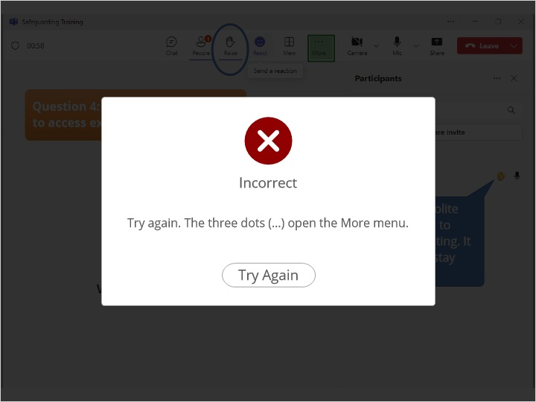

## 5.5 Camera

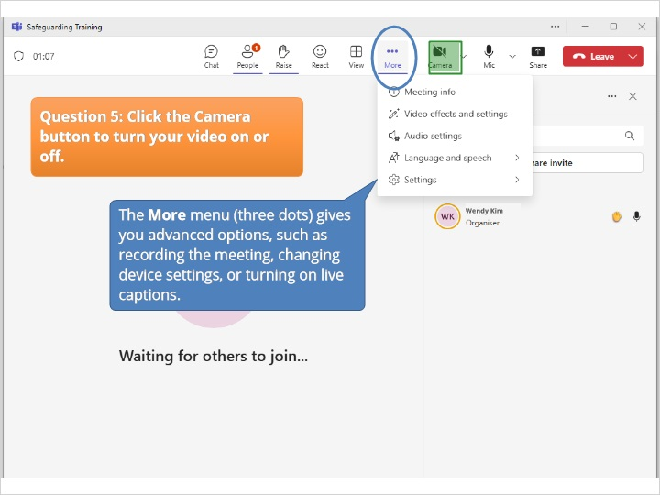

### Rectangular Hotspot 1 (Slide Layer)

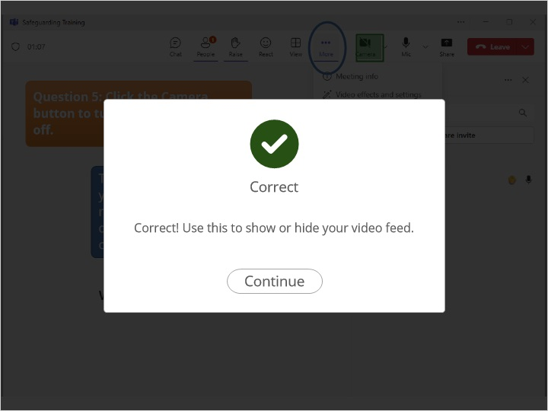

### Try Again (Slide Layer)

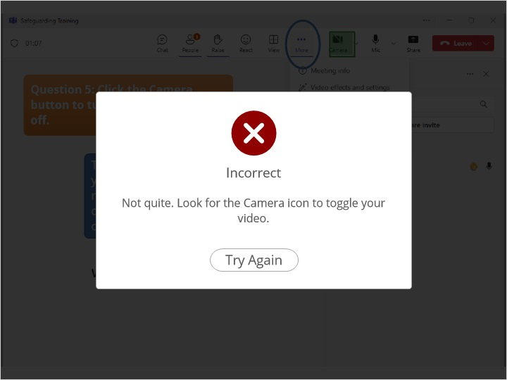

## 5.6 Microphone

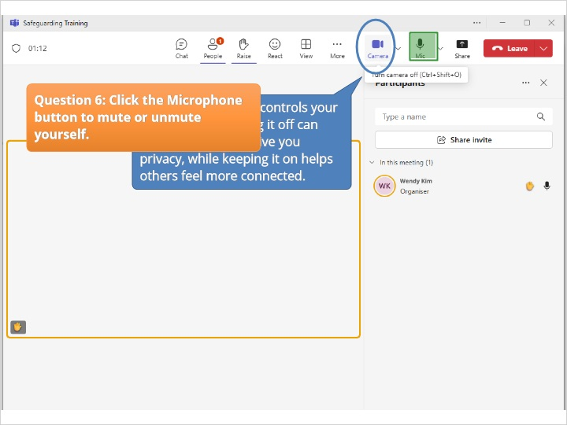

### Rectangular Hotspot 1 (Slide Layer)

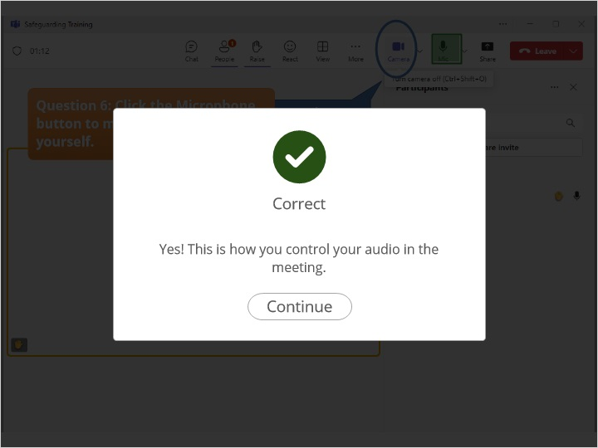

### Try Again (Slide Layer)

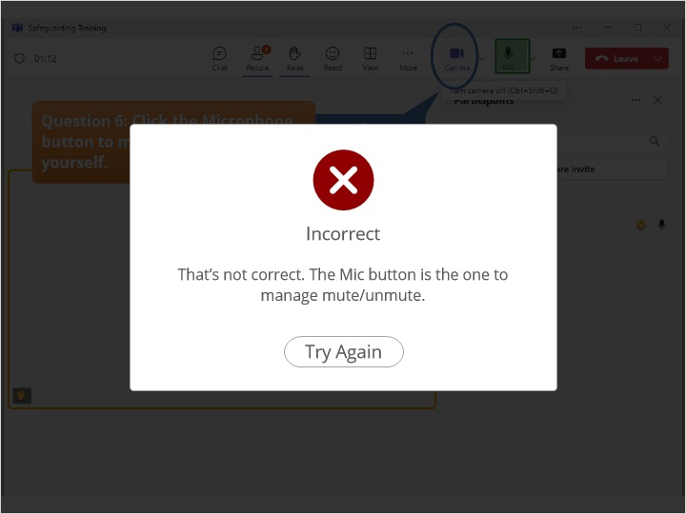

## 5.7 Share

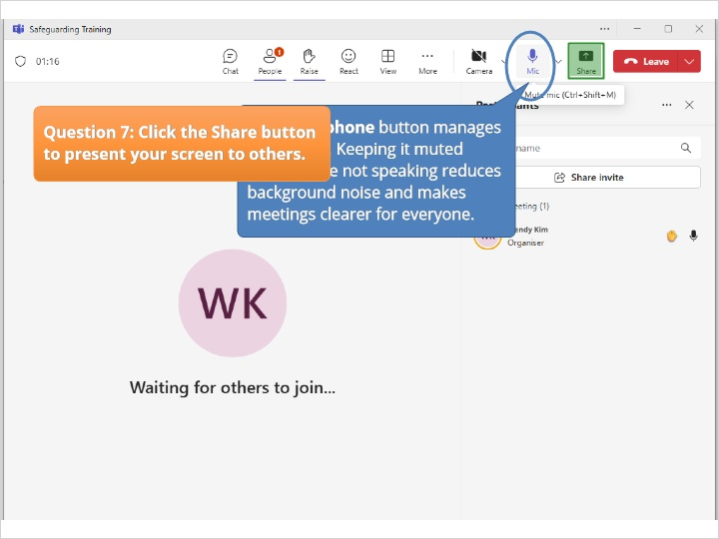

### Rectangular Hotspot 1 (Slide Layer)

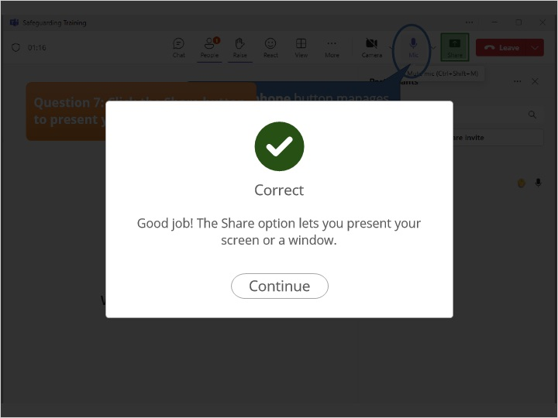

### Try Again (Slide Layer)

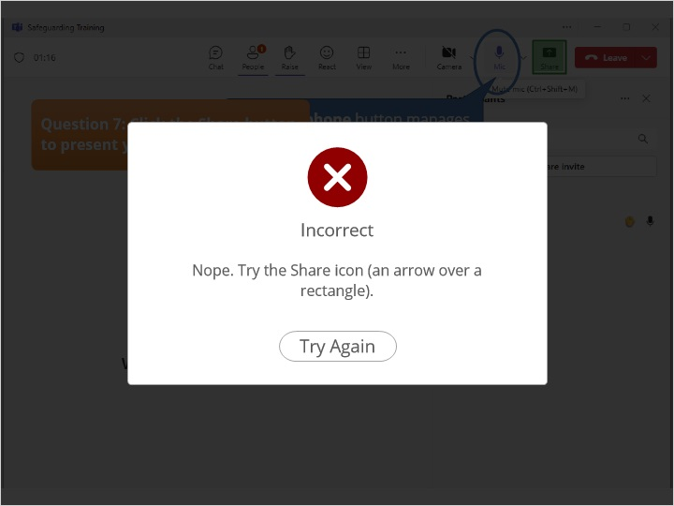

## 5.8 Leave

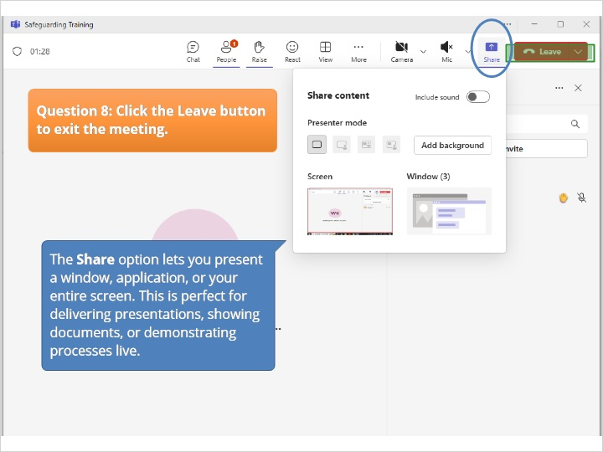

### Rectangular Hotspot 1 (Slide Layer)

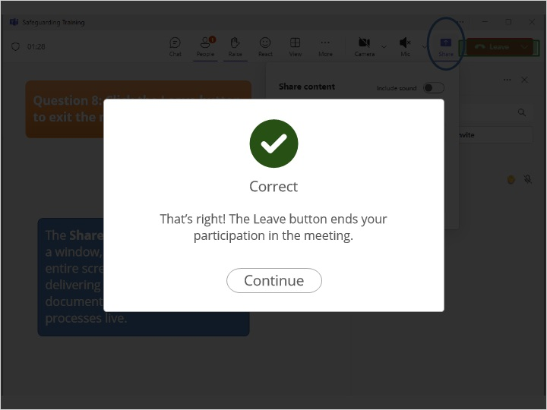

### Try Again (Slide Layer)

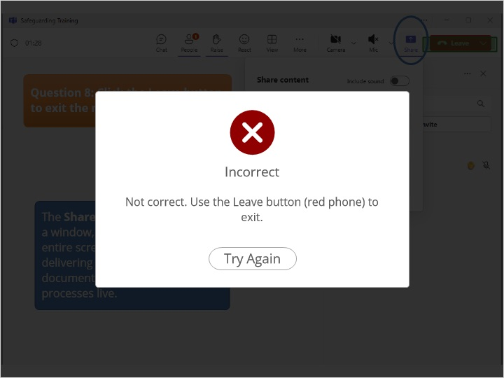

## 5.9 Task

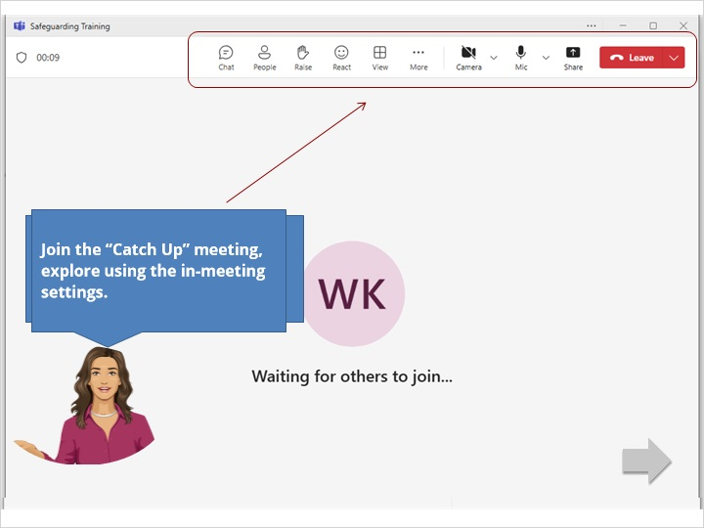

### Correct (Slide Layer)

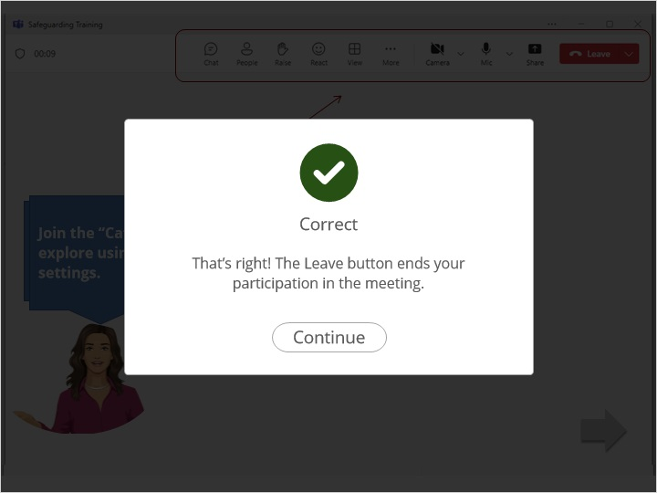

### Try Again (Slide Layer)

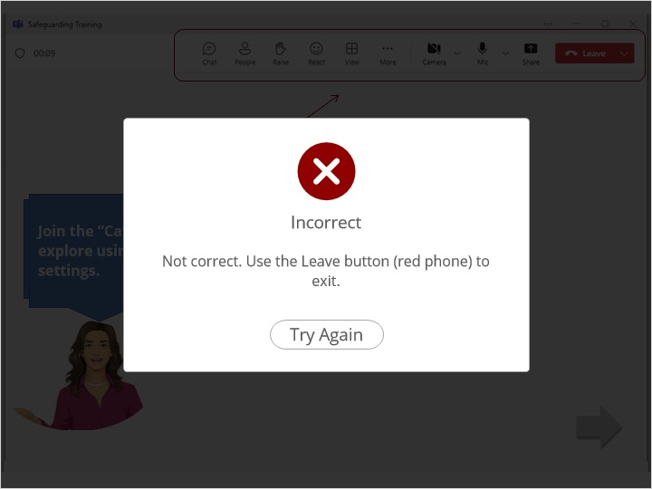

# 6. Ending &Recap

## 6.1 Recap

